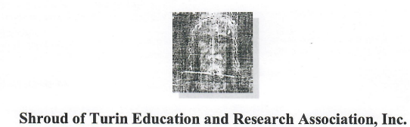
2408 Sovron Ct. / Dublin, OH 43016 / Phone: (614) 477-1480
Website: www.shroud.com / email: JMarino@shroud.com

MAIL A TAX DEDUCTIBLE CONTRIBUTION TO STERA, INC.

You can safely use PayPal to make a tax deductible contribution directly to STERA, Inc. by using the Secure Contribution Form online. Credit or debit card contributions are no longer being accepted. Contributions in the form of checks or money orders can also be made by postal mail.

Mail this form with your check or money order payable to STERA, Inc. and mail it to this address:

STERA, Inc.
2408 Sovron Ct.
Dublin, OH 43016

Thank you for your generosity. Your support is truly appreciated.

Joe Marino
Vice-President
STERA, Inc.

